**Let Credentialing Assistance pay your SANS renewal fees version 2.0**

**TL;DR** Yes, CA will once again pay SANS renewal fees. The only limit is the amount of TA you have left for the year. Details & the step by step to apply are below.

**Background**

The old ArmygnitED worked alright for CA but everyone had heard the horror stories regarding using it for TA. Some of us lived them. Apparently the site was so poorly ran that the DoD terminated the contract and hired a new company. The new site is here (https://www.armyignited.army.mil/student/public/welcome) and the good news is that they are now paying CA.

The new ArmygnitED site stood up around Oct 2022. They almost immediately paid my TA request for my UMGC class I had taken in Jun 2021, so that was promising. I put in a CA request to get my GMON renewal paid for immediately, only to find out that due to some Congressional snafu the funding would not be available until 10 Jan 2023.

Well it’s now 11 Jan 2023 and I was notified by CA first and then SANS later on that the renewal was paid. I figured I would update the original howto (<https://medium.com/@happycamper84/let-credentialing-assistance-pay-your-sans-renewal-fees-1b4c306810b1>) in case it helps anyone else.

This brings up the main point of using CA for SANS renewal fees; start the process early. I recommend putting in for CA the day you get the email notification from SANS that you can now pay the fee.

So without further ado let’s walk through the process together.

**SANS portal**

The process starts out the same as the old armyignited site. To recap, begin by navigating to [www.sans.org](http://www.sans.org) and login to your account. Hit ‘Certification History’.

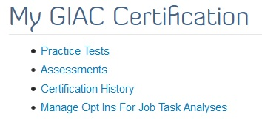

Scroll down to the cert that you want to renew. I am using GCED for illustrative purposes here. I didn’t bother making screenshots for GMON as the SANS portion didn’t change. Hence the price shown is the old one. Don’t worry, we aren’t paying it. CA is :P

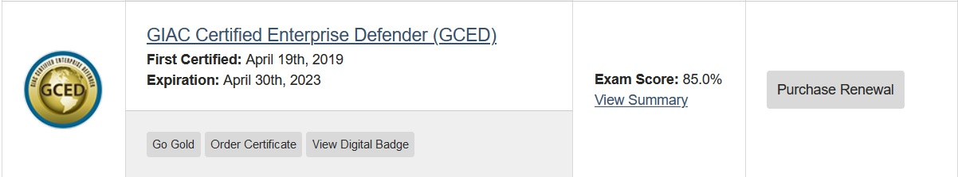

Select ‘Renew with CPEs’.

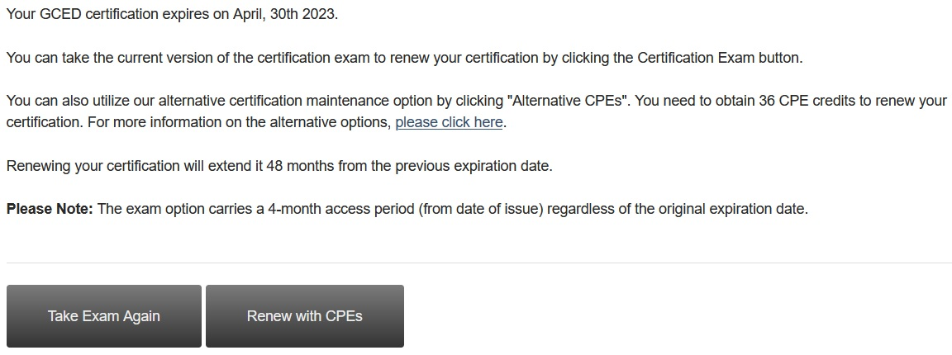

If you plan this out properly then there will only be $469 renewal fee on one SANS cert and the rest will be $239 (<https://www.giac.org/knowledge-base/renewal/>). Yes these prices went up recently. I am sure they will go up again shortly.

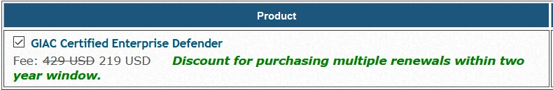

***This part is important!***

Make sure you select ‘Call in Credit Card’ as the payment option after you verify your information. This is the only option that will allow CA to pay. Then hit ‘Review Order’

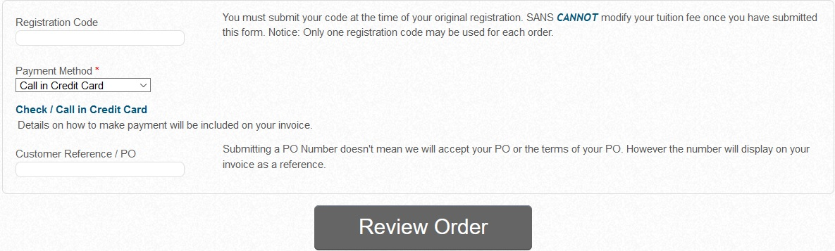

Verify the amount and hit ‘Place Order’.

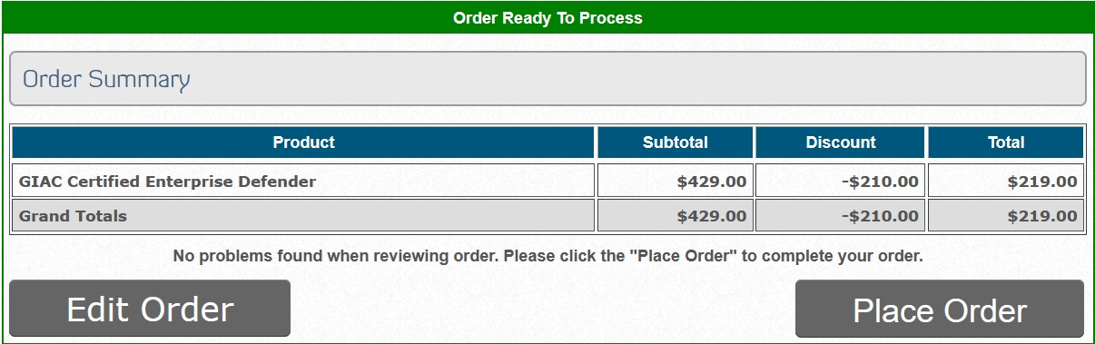

Hit “Please print a copy … for your records”. Print to PDF. Save that PDF somewhere handy. You will need it shortly to complete the process on the ArmyignitED portal.

**ArmyignitED**

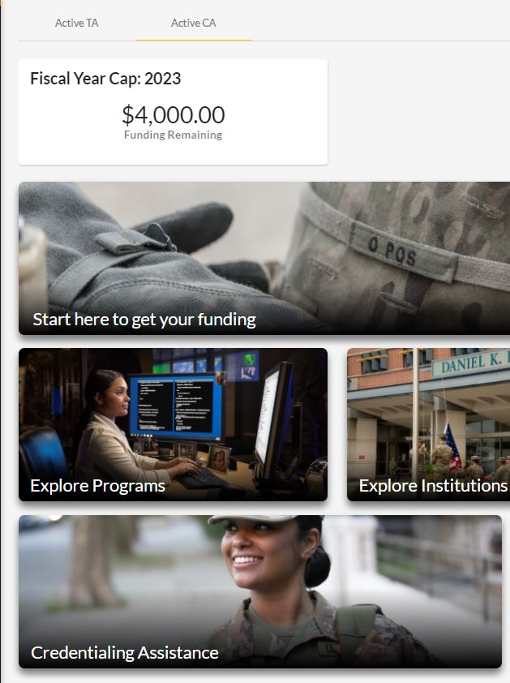

The new site starts out much like the old one. You login, select CA, select that you want a cert that is MOS related. The difference is that you create an education goal first, kinda like how you have to create one for TA.

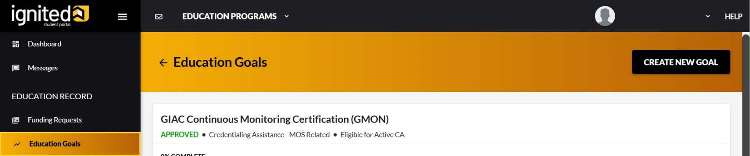

Select ‘Credentialing Assistance – MOS Related’

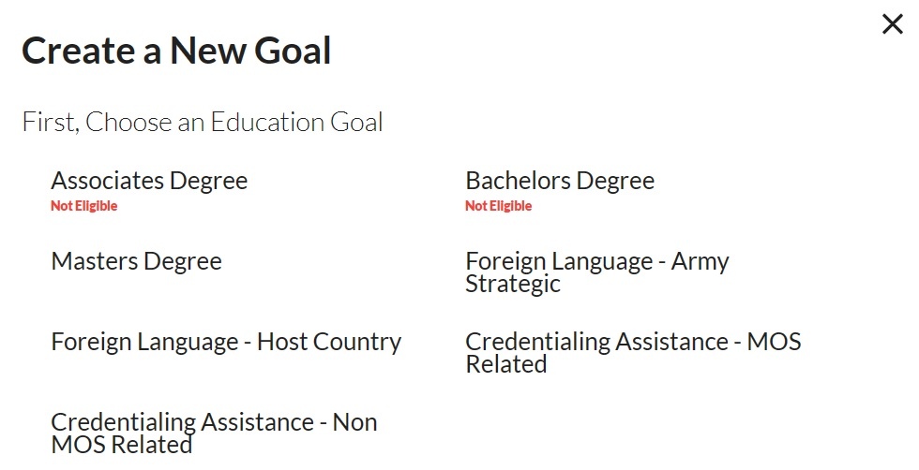

Search the SANS cert that you are renewing

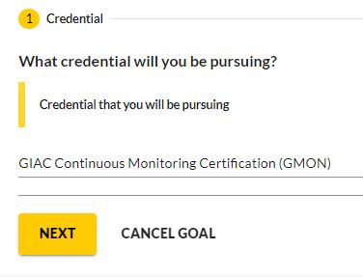

***This part is important!***

Upload the PDF renewal fee quote that you saved from SANS earlier and select ‘Submit Goal’.

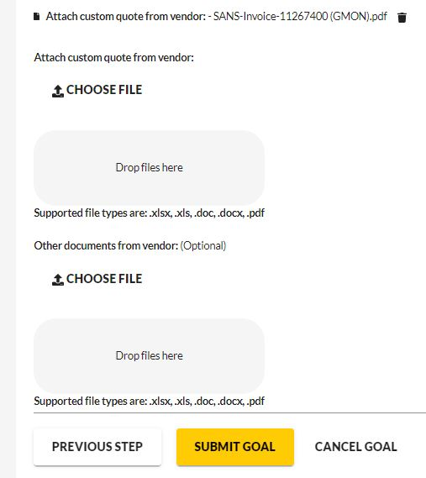

**Apply for funding**

We now come to the final step of applying for funding. Once the education goal is approved select ‘Apply for Funding’.

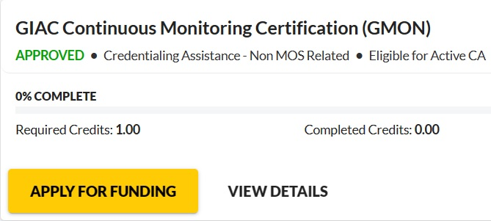

Verify your information and proceed.

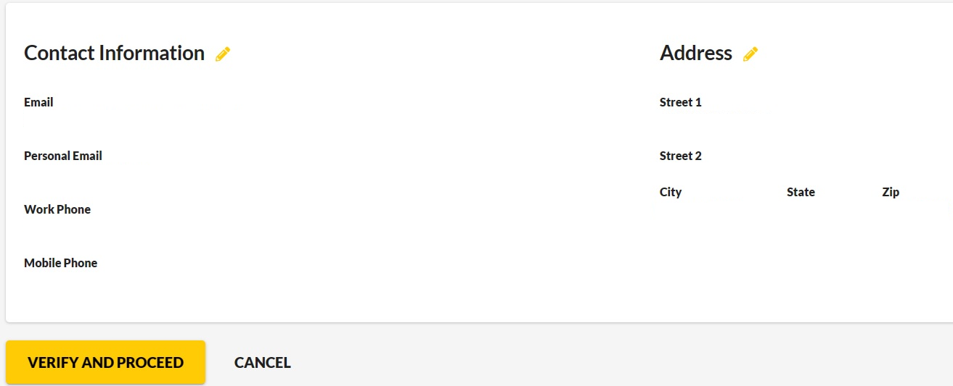

Check all the boxes that your agree to the terms of CA and continue.

Select whether you are applying from a deployed location.

Please note that you must select a start date that is 90 days out. This is why it’s best to start this process as soon as you hit your 2 year renewal window. Don’t wait until the last minute!

Pick any date really that is a month or more after the start date as your end date. You just need to give yourself enough time to submit your ‘Proof of Completion’ after CA pays SANS.

Search ‘SANS’ in both boxes and select what shows up. It should look like the below.

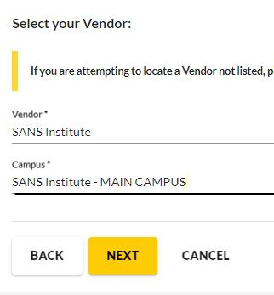

***This part is important!***

The old ArmyignitED had its counterintuitive parts of the process. This is the new site’s one.

Select ‘Add Training’.

DO NOT select ‘Add Exam’. That path leads to asking for an exam voucher, which will not match your PDF invoice, and will cause your request to get kicked back about a month later. If this happens you have to submit a new request, with the obvious time delay involved.

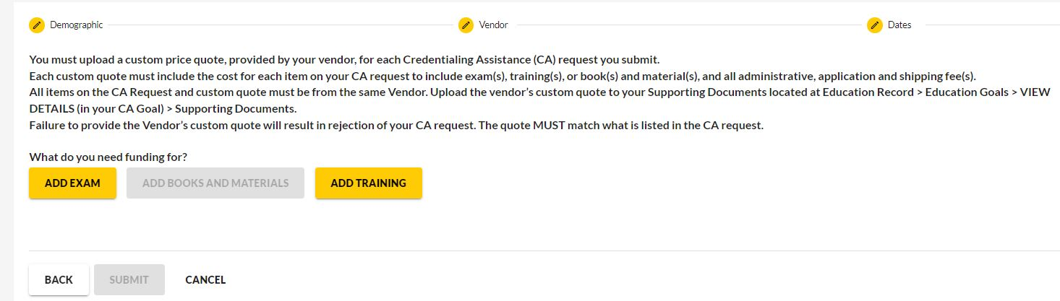

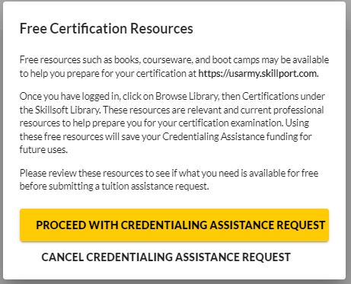

We are then presented with the elusive option to apply for payment of the renewal fee. Select it, with prejudice.

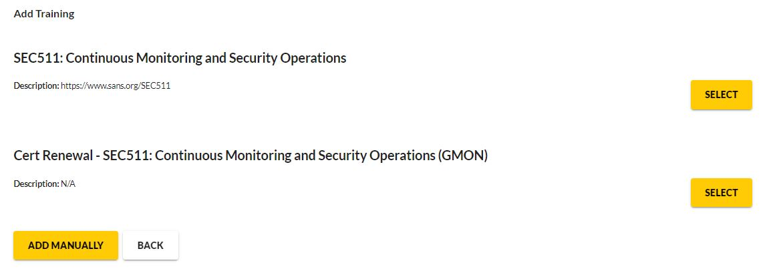

Don’t worry if the site shows the full renewal fee amount of $469. As long as you uploaded the PDF invoice then CA will pay the right, discounted amount.

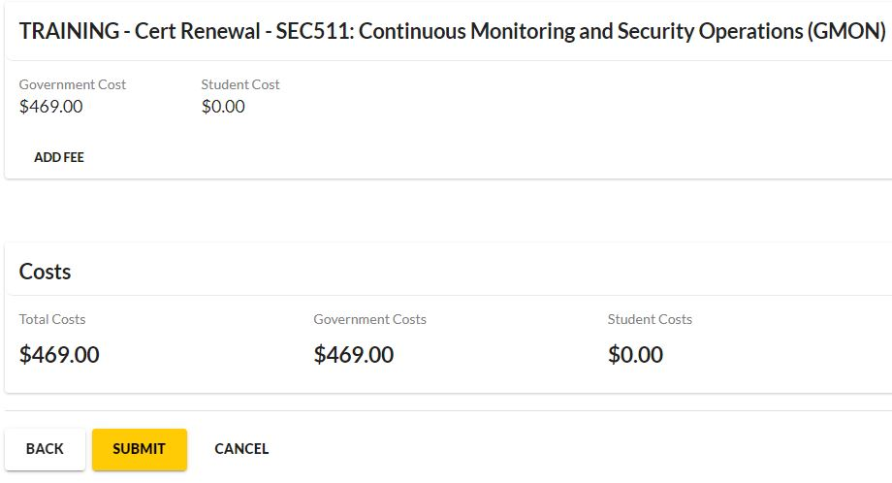

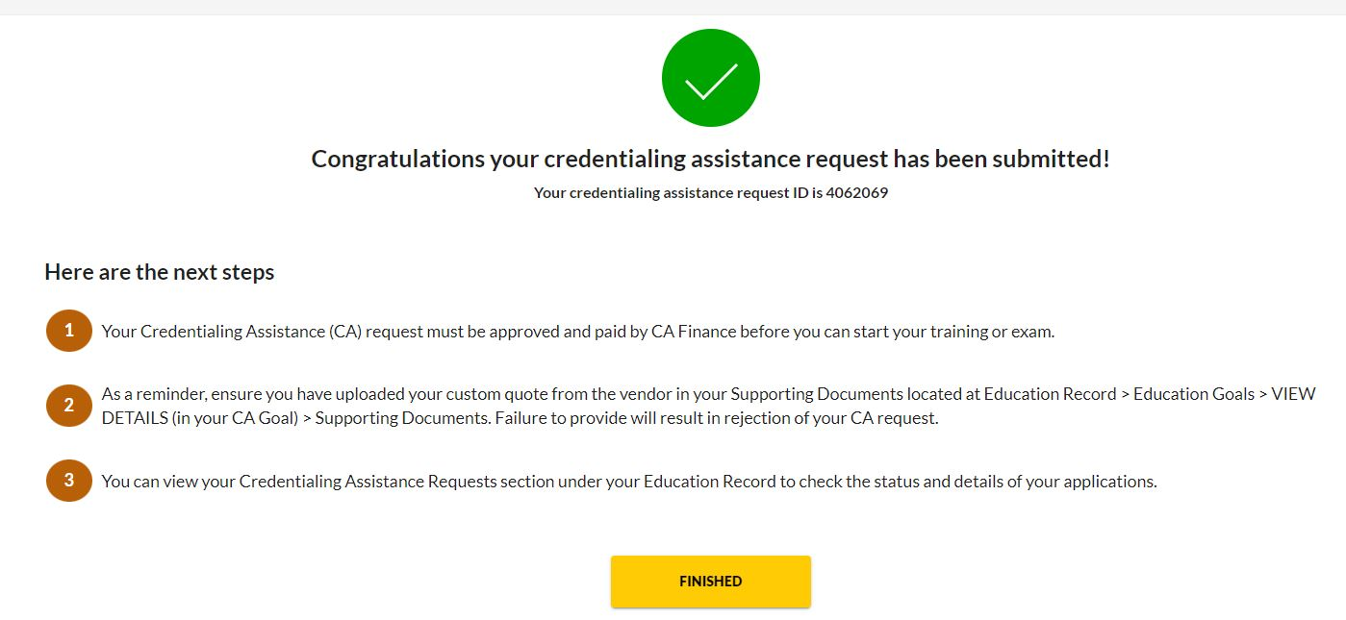

Hit ‘Submit’, hit ‘Finished’, and rejoice.

**Submitting a PDF once CA pays**

CA just paid my GMON renewal 2 days ago, so this part is subject to an update if ArmyignitED tells me I did it wrong. I submitted my ‘Proof of Completion’ from the ‘Education Goals’ screen by selecting my GMON goal and then selecting ‘View Details’.

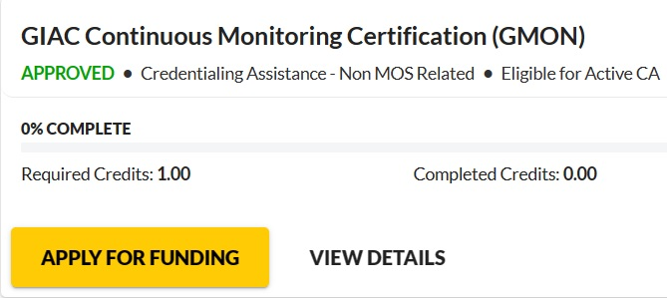

Hit ‘Supporting Documents’, ‘Add’, Select ‘Certificate of Completion’ from the drop down, ‘Choose File’, select your PDF, and ‘Add’.

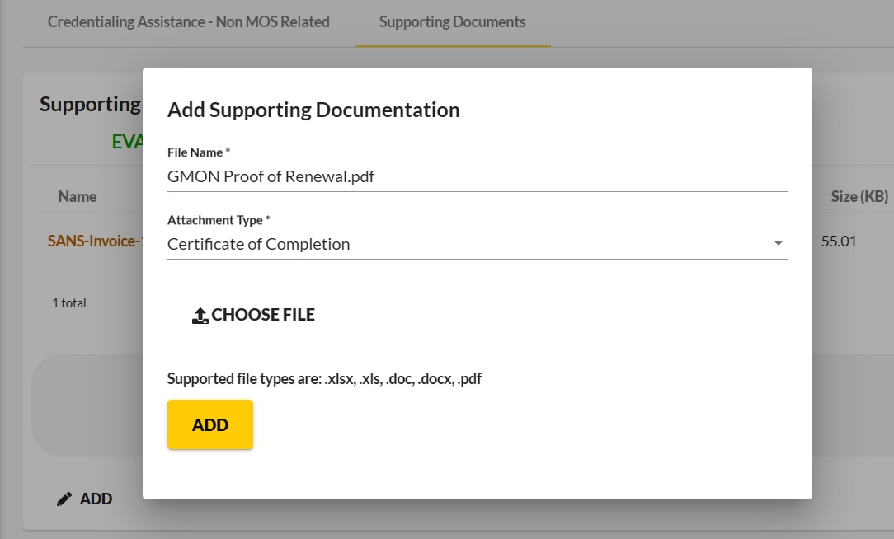

I had accidentally created two education goals for this renewal as I really had no idea what I was doing at first. I started this process the day the new ArmyignitED site stood up. There was a good deal of fumbling around and hitting random buttons involved in getting this request submitted. I took notes and screenshots along the way so that I would remember WTH I had done the next time around.

I have said it before, but everything here is really just my notes. I go back and reference them myself all the time. If it helps anyone else then great, but ‘me in a year from now’ is really my intended audience.

On a sidenote, my ‘Proof of Completion’ for a renewal has always just been a copy/paste from SANS site showing the invoice was paid and the cert’s new expiration date. I just make a quick & dirty PowerPoint and then print it to PDF as the new ArmyignitED doesn’t accept *.pptx. This method was always acceptable on the old ArmyignitED site and looks like the below.

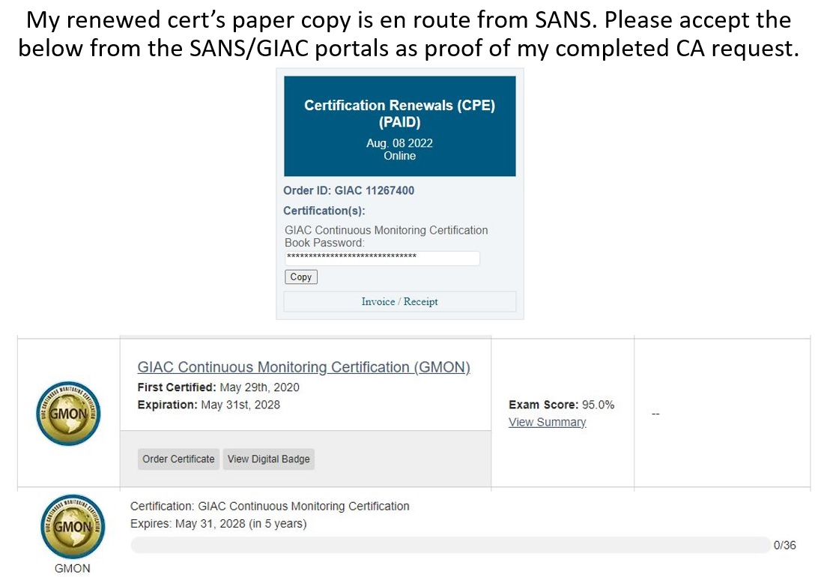

**Download the new books**

The last step is to go back to the SANS portal, download the books for the course that goes with the cert you just renewed, and save the PDF password. The DoD just paid good money for them, so I’d recommend downloading the course ISO as well.

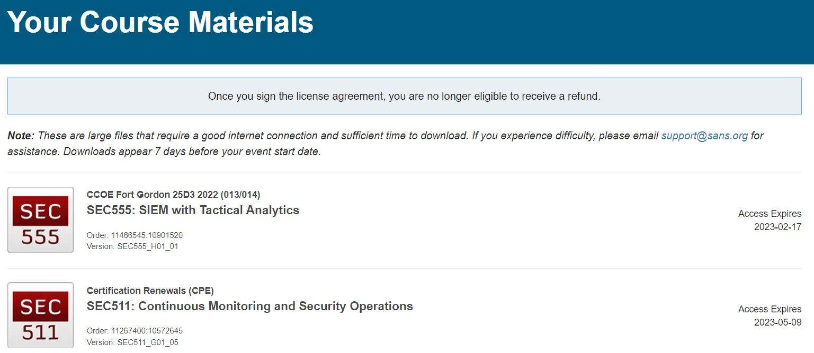

**Learning is free, SANS … not so much**

I have said it many times before, but I absolutely love CompTIA. They are a non-profit, their exams are some of the most affordable ‘vendor neutral’ 8570.01-M compliant ones out there, and they have one of the lowest renewal fees of anyone. Their fee is also a flat rate. It doesn’t matter if you have 1 CompTIA cert or 10, its $50 a year.

ISC2 is also a non-profit. They share many of CompTIA’s pros. Their fee is higher at $125 a year, but it is also a flat rate.

By contrast SANS is a for profit business. Their prices reflect this. Their renewal fees are per cert. If the DoD has given you vouchers for 8 SANS exams then the fees are ($469 + (7 * $239)) = $2,142 every 4 years. That’s $535.50 a year. I’ll let that sink in for a moment.

Ok we’re back. A lot has happened since we wrote the original ‘Let Credentialing Assistance pay your SANS renewal fees’ (<https://happycamper84.medium.com/let-credentialing-assistance-pay-your-sans-renewal-fees-1b4c306810b1>). We have written something like 55 howtos on here. The vast majority of those are regarding setup & security of a hybrid AD environment. We learned this topic from a combination of two dirt cheap Microsoft certs, the screaming deal that is CRTP, a cheap refurbished server, free software, and lots of Google.

The now retired MCSA was $495 total for 3 exams and is ‘Good for Life’. The new Microsoft exam dealing with Identity & Access Management in a hybrid AD environment would have been $165, but was free thanks Microsoft’s Enterprise Skills Initiative. There is no renewal fee. One just has to brush up on the free Microsoft Learn and pass a free quiz to renew. Pentester Academy’s Certified Red Team Professional (CRTP) was $500 for the course, 3 months of lab access, and a 100% hands on exam.

VMware gives away a free version of ESXi. Microsoft gives away evaluation copies of their stuff. An Azure AD Premium P2 license is $9 a month. Here at test.local we got our refurbished sever for $320 ‘out the door’.

The point is that we run this lab on an absolute shoe string budget. We learned how to do really everything we have written about on here either for free or for $108 a year. Our future plans include a M365 license at $23 a month including Intune.

We still have a long ways to go but we won’t get there by spending 8k.

Study well my friends.

**Summary**

If this walkthrough helps someone else then that’s great. I am all for letting CA pay my SANS renewal fees and using my paycheck for mundane things like groceries or the utility bill.

If you read this far and you have any questions then just message me on FB, work email, Teams, etc.

V/R

Rich

**References**

The original CA for SANS renewal fees howto: <https://happycamper84.medium.com/let-credentialing-assistance-pay-your-sans-renewal-fees-1b4c306810b1>

New ArmygnitED site: <https://www.armyignited.army.mil/>

SANS renewal prices, CPEs, etc: <https://www.giac.org/knowledge-base/renewal/>